Chapter 8, Solution 18.

When the switch is off, we have a source-free parallel RLC circuit.

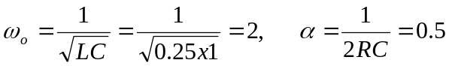

I_{o}(0) = i(0) = initial inductor current = 100/5 = 20 A

V_{o}(0) = v(0) = initial capacitor voltage = 0 V

v(0) =0 = A₁

Thus,

